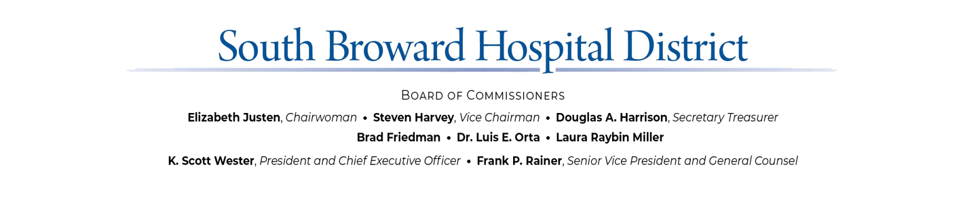

EMERGENCY SPECIAL MEETING OF THE
SOUTH BROWARD HOSPITAL DISTRICT BOARD OF COMMISSIONERS

****CANCELED ****
SPECIAL MEETING
RE: EXECUTIVE PERSONNEL MATTERS
FRIDAY, SEPTEMBER 20, 2024

AT 5:00P.M.

EXECUTIVE CONFERENCE ROOM
3111 STIRLING ROAD
HOLLYWOOD, FLORIDA

A G E N D A

- Call to Order – Public Meeting Certification / Public Comment
- Executive Personnel Matters
- New Business
- Adjournment

